Configure “Router 2”
Reset the router to factory defaults.

Connect to the router’s management interface:
Type 192.168.1.1 in your browser’s address bar.
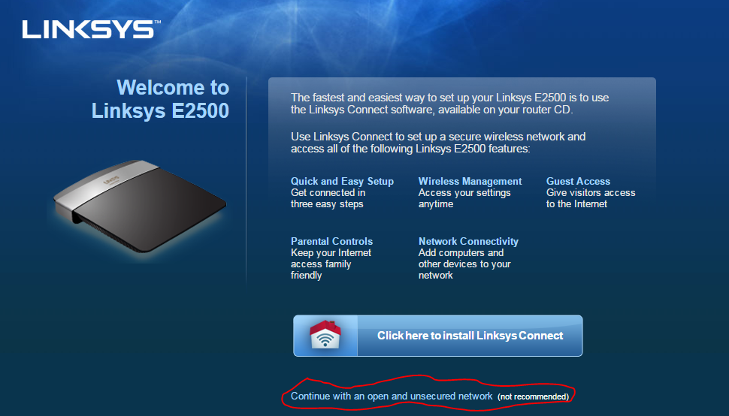
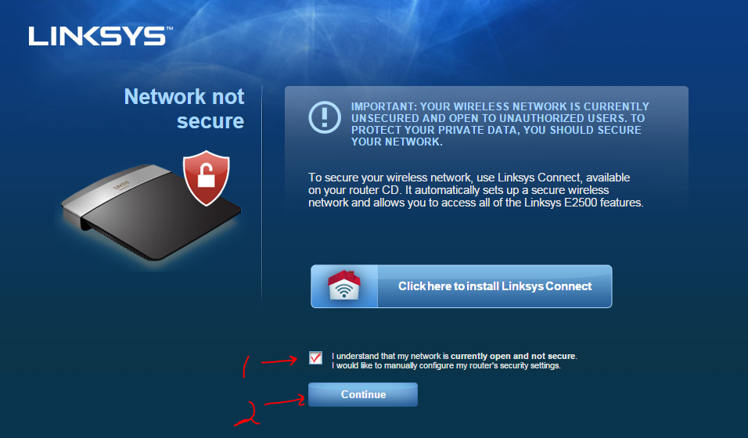

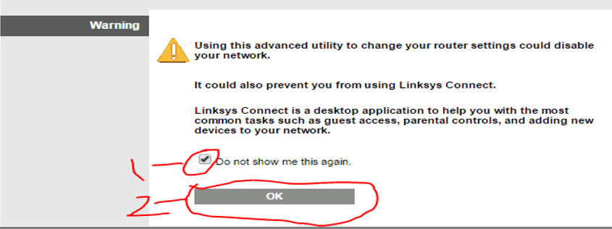

Login to the router’s management interface:
Username: admin
Password: admin

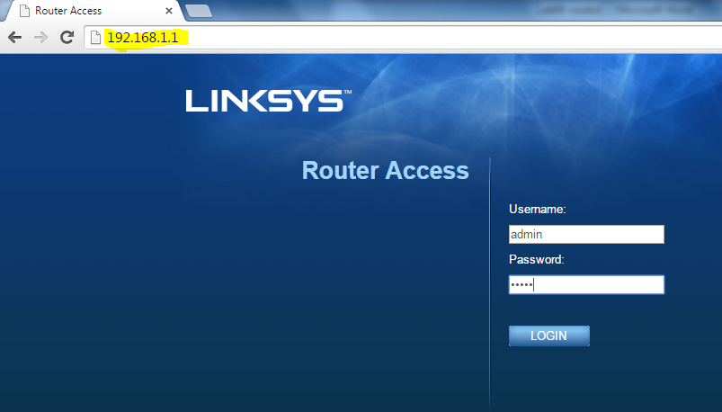

Configure Router IP Addresses
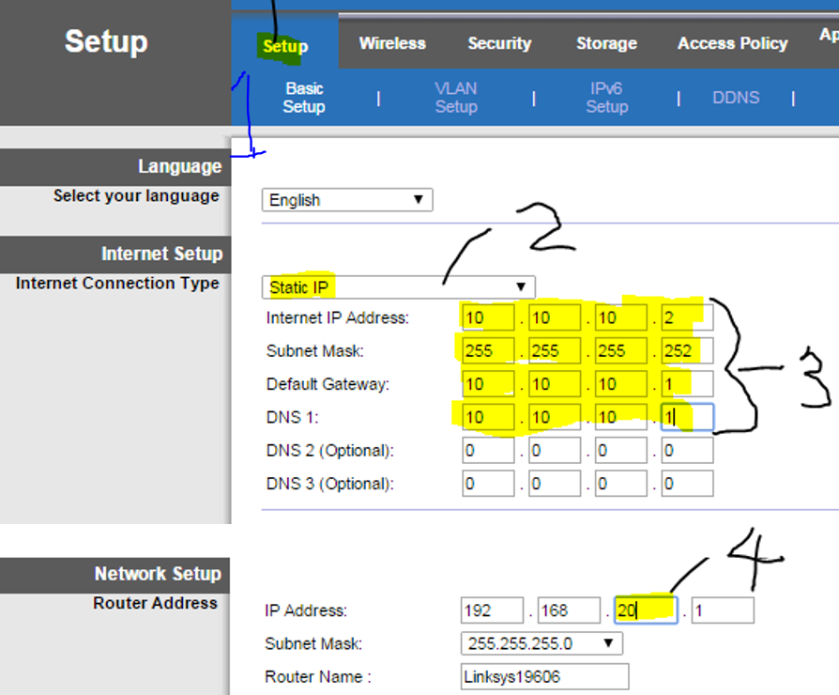
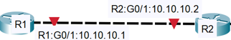
WAN
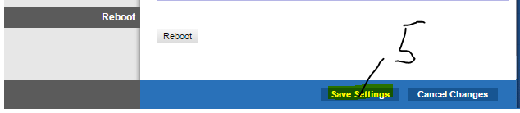
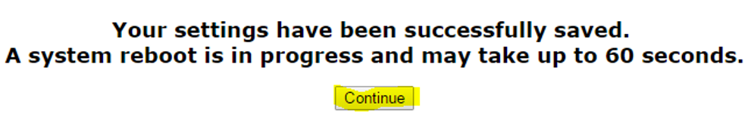
Wait for the router to reboot, and then reconnect to the router’s new IP address @192.168.20.1
Disable NAT (Network Address Translation: Translates a public IP address to a private IP address.

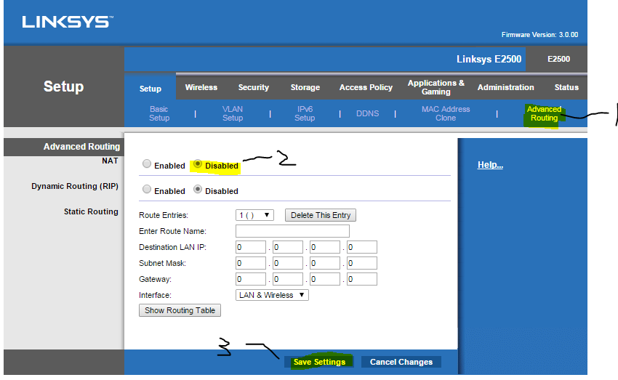
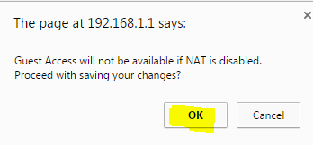
Wait for the router to reboot, and then reconnect to the router’s new IP address @192.168.20.1
Allow Anonymous Internet Request
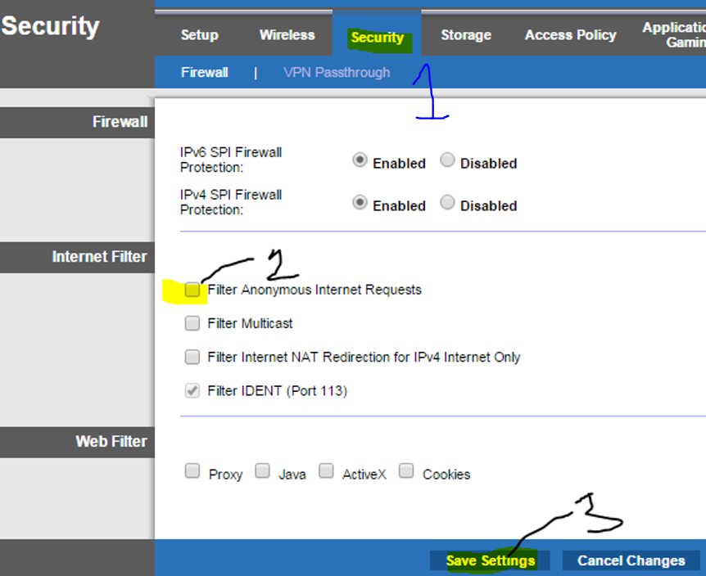
uncheck


Network Connectivity Tests
- Local Connectivity Tests
  - Ping 192.168.20.1 (your local port)
  - Ping 10.10.10.2 (your WAN port)

Please wait for your partner to complete her/his router configuration before performing remote connectivity tests.

- Remote Connectivity Tests
  - ping 10.10.10.1 (partner WAN)
  - ping 192.168.10.1 (Partner port)

You cannot proceed until both local and remote connectivity tests have succeeded.
Record your laptop’s IP and MAC addresses on the network topology diagram.
Record your router’s MAC address on your network topology diagram.
Record your partner’s laptop IP and MAC addresses on your network topology diagram.
Record your partner’s router MAC address on your network topology diagram.
Identify each laptop’s role – one is a webserver and the other a web client.
Return to Task1 step 8 of the “Lab04 – In Lab Activities” document.

